Clerk to the Council: JANICE RAE (ACTING CLERK)
Telephone 07457 368 323, Email info@allonby-pc.org.uk

9th May 2024

Dear Parishioner,

The Annual Meeting of Allonby Parish will be held in the Parish Hall on Wednesday 15th May, 2024 at 7.30pm. The meeting will be followed by the Annual Meeting of the Parish Council.

Yours sincerely,
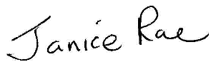

Janice Rae
Acting Clerk

AGENDA

APM/1 | Apologies for absence  To receive apologies for absence.
APM/2 | Minutes of the previous Parish Meeting  To approve the minutes of the previous parish meeting.
APM/3 | Chairman’s report  To receive the Chairman’s annual report.
APM/4 | Reports from outside bodies  To receive any reports from local groups/organisations.
APM/5 | Public Participation  Members of the public have the opportunity to raise any items of interest or matters of concern relating to the Parish.

